## INTERNSHIP REPORT

## ON

_

***Submitted to***

**Rashtrasant Tukadoji Maharaj Nagpur University, Nagpur *in partial fulfillment of the requirement for the degree of BACHELOR OF TECHNOLOGY***

***in***

***Computer Science & Engineering***

**Submitted By**

**Mr._**

## 

## under the Guidance of

***_***



**Department of Computer Science & Engineering Government College of Engineering**

**Nagpur – 441108 (M. S.) 2022-2023**

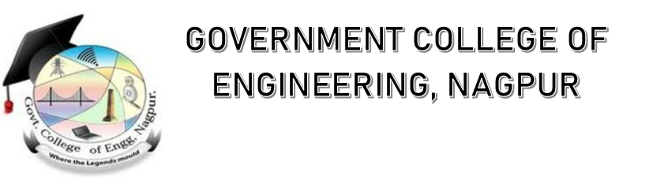

**Department of Computer Science & Engineering Government College of Engineering**

***Certificate***

This is to certify that this record contains the internship report of

**_** of 2nd year/ 4thsemester ,

Roll No. **_** has successfully completed the internship program during the academic session _.

Guided By

_

**ACKNOWLEDGMENT**

I would like to take up  this opportunity to extend my gratitude and

appreciation to my mentor, Prof. _, who has been a consistent source of

support and advice throughout this internship. I shall be forever thankful to

her for the support and encouragement she has provided me throughout

the internship program.

Mr. _

Computer Science & Engineering Government College of Engg., Nagpur

|  |
| --- |
| Contents   * *A*bout the Organization |

* **Position at theOrganization**
* **My Development**
* **Learning Outcome**
* **Internship Certificate**
* **Conclusion**

***A*bout the Organization**

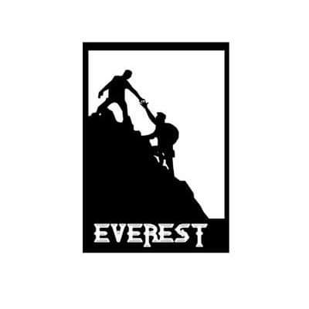

*Team Everest started it’s journey in 2006 when Karthee Vidya, founder of Team Everest finished his engineering and joined the corporate world.  
  
He donated from his first month salary and also collected donations from 3 of his friends. With Rs 4000 in hand, he visited a rural school in Tamil nadu where 70% of the children were child labourers.   
  
He paid them school fees, donated uniforms, notebooks and other stationaries.  
  
From there we have grown to what we are today with the help of thousands of Volunteers. The founder has quit his high paying corporate job and doing full time social work with Team Everest now.  
  
We believe in the power of endless love every person has and want to tap that potential to make a difference in this world.  
  
Team Everest is one of the biggest youth run NGO in India. Team Everest’s focus is on motivating individuals to volunteer at least once a month (12/365) and make a difference by providing quality education to underprivileged children through volunteering.*

**Position at theOrganization**

Offer letter:

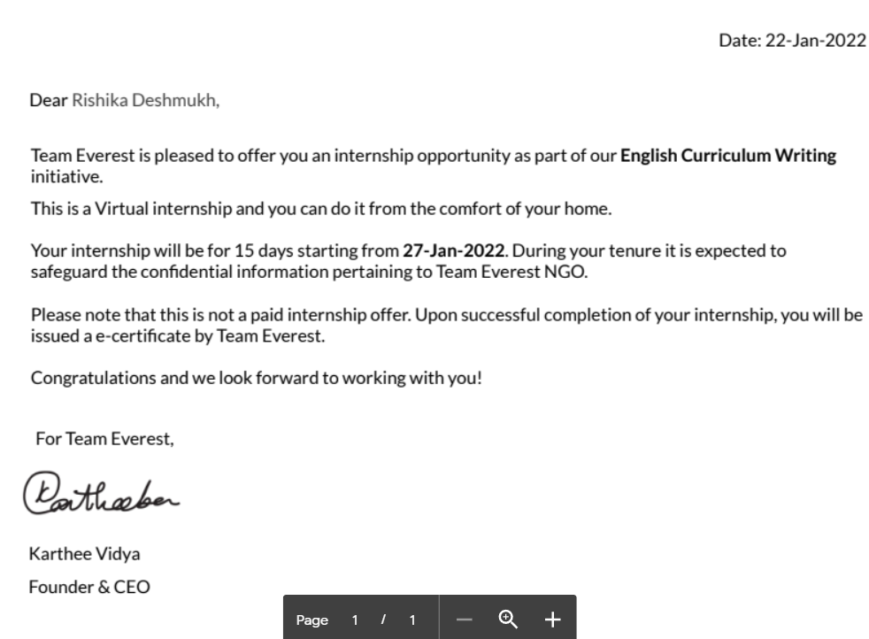

I applied for internship at Team Everest through a platform called INTERNSHALA. The internship was for 2 weeks with no stipend.

After hiring I immediately received my offer letter through email.

Internship tenure: 2 weeks

From _

Internship mode : remote /virtual

**My Development**

* Expanded my ideas over Creative writing and grammar in English.
* Learntaboutthework environment and thought process of content creation.
* Learnt about the perspective of other interns and their style of writing.

**LearningOutcome**

1. Time Management: We were expected to complete 20 sessions within 2 weeks, which is reasonable but we did have college so time management is one more thing I learnt through this internship.
2. Responsibility: Another thing I learnt during the internship was taking responsibility for my content.
3. Creative Content: During the internship, I learned to get creative, getting ideas from the most trivial things happening in life to general news anything can help in content writing.
4. Verbal Communication: My communication skills improved a lot as I had to attend orientation sessions that gave me a chance to speak up my doubts and thoughts.

**Internship Certificate**

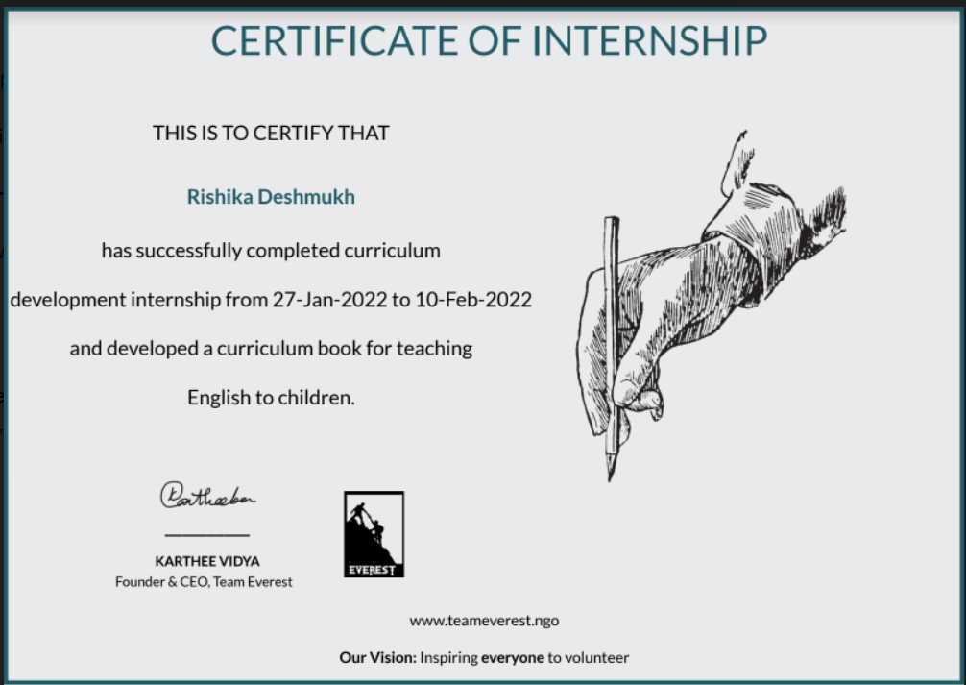

**Conclusion**

I am really grateful of TeamEverst for giving the chance to be part of their organization and hope to be part of them again in the future.

I take this opportunity to express my profound gratitude and deep regards to my internship trainer _ for their

exemplary guidance, monitoring and constant encouragement throughout the course of this internship.